

**Name: Serene Quek**

**CZ4003 Computer Vision Lab Assignment 2**

**3. EXPERIMENT**

**3.1 Edge Detection**

a) Download `macritchie.jpg’ from edveNTUre and convert the image to grayscale.



Figure 1: Gray Scale Image of 'macrcropped.jpg'

b) Create 3x3 horizontal and vertical Sobel masks and filter the image using conv2.

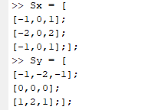

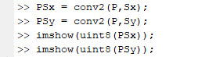

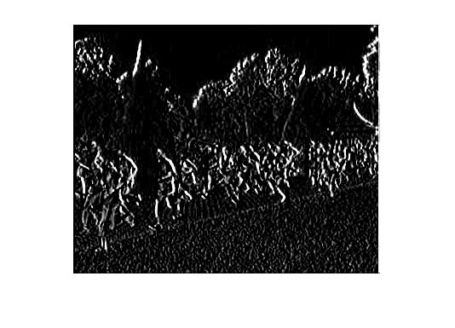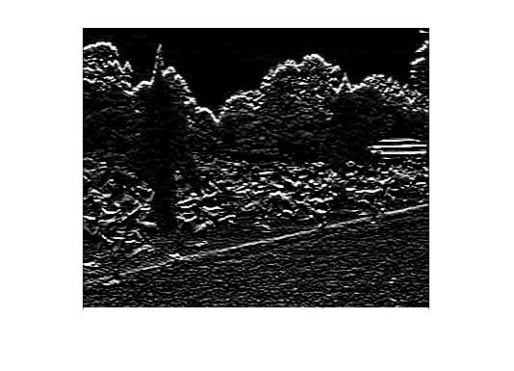

Figure 2: Convolution of P with Sx Figure 3: Convolution of P with Sy

What happens to edges which are not strictly vertical nor horizontal, i.e. diagonal?

The diagonal edges are separated into horizontal and vertical components thus allowing the silhouette of trees which are not entirely vertical nor horizontal to be observed.

c) Generate a combined edge image by squaring the horizontal and vertical edge images and adding the squared images.



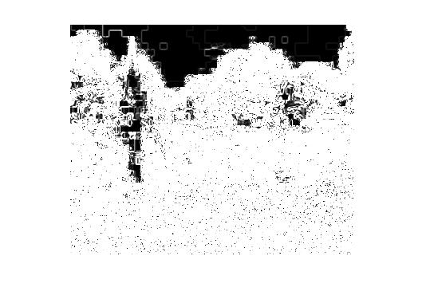

Figure 4: Combined edge image

Suggest a reason why a squaring operation is carried out.

The squaring operation would give the gradient magnitude. The absolute gradient magnitude can be approximated by the equation:

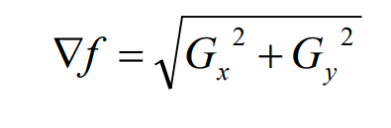

By following this equation, we would yield a clearer image of the edges as shown below:



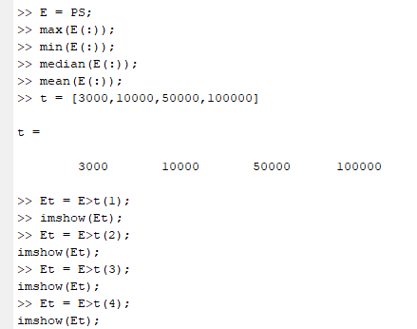d) This creates a binary image. Try different threshold values and display the binary edge images.



|  |  |
| --- | --- |
| A picture containing tree, photo, black  Description automatically generated  Figure 5:Threshold = 3000 | A close up of a womans face  Description automatically generated  Figure 6:Threshold = 10000 |
| A close up of a logo  Description automatically generated  Figure 7: Threshold = 500000 | A close up of a logo  Description automatically generated  Figure 8:Threshold = 100000 |

What are the advantages and disadvantages of using different thresholds?

* An advantage of thresholding is that it is simple to implement while producting acceptable results. At lower thresholds, the benefit is that more edges are detected, however, more noise is observed.
* On the other hand, at higher thresholds, less edges are detected but less noise is interfering with the edge detection.
* This means that we must select an appropriate threshold ensure that there is minimal noise but at the same time preserving the edges.

e) Recompute the edge image using the more advanced Canny edge detection

algorithm with tl=0.04, th=0.1, sigma=1.0

>> E = edge(I,’canny’,[tl th],sigma);

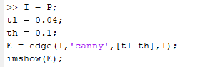

Figure 9: Edge Image using Canny Edge Detection

1. Try different values of sigma ranging from 1.0 to 5.0 and determine the effect on the edge images.

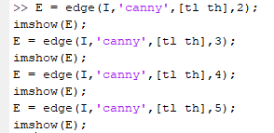

Figure 10: Sigma = 2

Figure 11: Sigma = 3

Figure 12: Sigma = 4

Figure 13: Sigma = 5

What do you see and can you give an explanation for why this occurs? Discuss how different sigma are suitable for (a) noisy edgel removal, and (b) location accuracy of edgels.

* It is observed that as sigma increases from 1 to 5, noisy edgels are successfully removed from the image, but the edge details consequently decrease as well, thus location accuracy of the of edgels decreased.
* A decrease in location accuracy may be due to the initial Gaussian Edge Filtering Step where if sigma increases, the more the image is smoothed. Thus resulting in more difficulty in identifying the edgels as more pixels are suppressed, since lesser pixels would be at local maxima.

(ii)

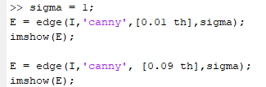

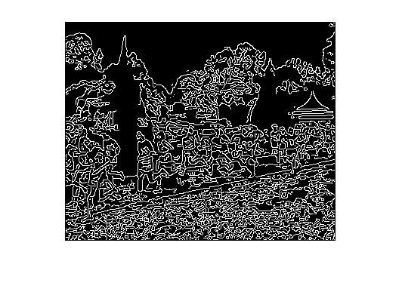

Figure 14: tl = 0.01

*Figure 15: tl = 0.04*

Figure 16: tl = 0.9

Try raising and lowering the value of tl. What does this do?

* Raising the value of tl reduces the amount of noise without significantly affecting the location accuracy of the edgels as seen in the difference between Figure 14 and 16 where 14 has much noisier edgels than 16.

How does this relate to your knowledge of the Canny algorithm?

* Since Canny Edge Detector uses Hysteresis Thresholding, values below the threshold will be ignored. i.e. any value below tl=0.01 or tl=0.09 will not be considered and if a pixel value is above the threshold value, it will be considered an edge. Thresh must be [low high], where 0 < low < high < 1.
* Since as tl increases more pixels will fall below the threshold and become ignored. Thus, resulting in a reduction in noisy edgels.

**3.2 Line Finding using Hough Transform**

a) Reuse the edge image computed via the Canny algorithm with sigma=1.0.

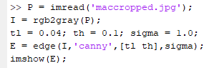

b) Read the help manual on Radon transform and explain why the transforms are equivalent in this case. When are they different?

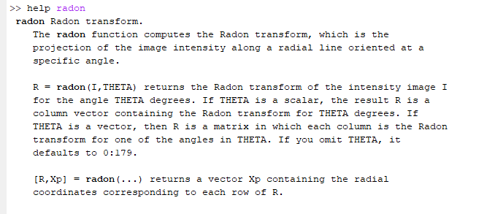

By conducting some research, we understand the Hough Transform is discrete while Radon is continuous, since discrete inputs have been used in the radon transformation, this means that a discrete output was given thus equivalent to the output of a Hough transformation.

They are different when the input is continuous.



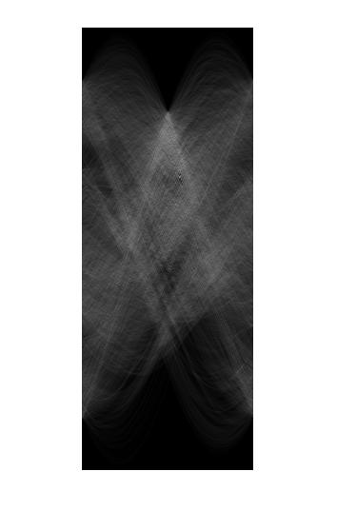

c) Find the location of the maximum pixel intensity in the Hough image in the form of [theta, radius].



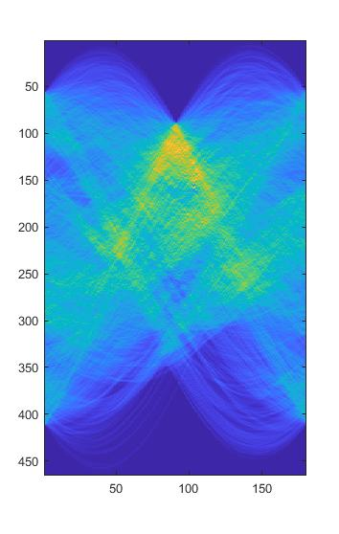

Theta = 103; and Radius = 157; Therefore, [theta, radius] = [103, 157].

d) Derive the equations to convert the [theta, radius] line representation to the normal line equation form Ax + By = C in image coordinates.

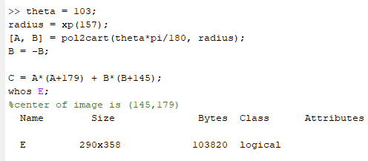

Since the Hough transform is done with respect to an origin at the center of the image, I converted the image coordinates where the origin is in the top-left corner of the image where we know the size of the image is 290x358.

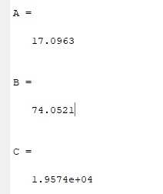

e) Based on the equation of the line Ax+By = C that you obtained, compute yl and yr values for corresponding xl = 0 and xr = width of image - 1.

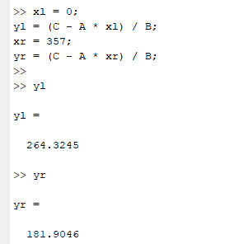

f) Display the original ‘macritchie.jpg’ image. Superimpose your estimated line by



* As seen in the above image, the line is almost aligned perfectly but not entirely. Errors may have been due to the line in the image being not completely straight so the line would not follow a linear function completely.
* Additionally, since we are using radon transformation on a discrete function a loss in accuracy might have occurred.

**3.3 3D Stereo**

a) Write the disparity map algorithm as a MATLAB function script which takes two arguments of left and right images, and 2 arguments specifying the template dimensions. It should return the disparity map.

b) Download the synthetic stereo pair images of ‘corridorl.jpg’ and ‘corridorr.jpg’,

converting both to grayscale.



~~

Grayscale ‘corridorl.jpg’



~~

Grayscale ‘corridorr.jpg’

c) Run your algorithm on the two images to obtain a disparity map D, and see the

results via

>> imshow(-D,[-15 15]);

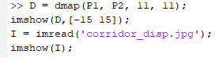

|  |  |
| --- | --- |
| A close up of a door  Description automatically generated  Original Disparity Map | A picture containing photo, jack, wall, indoor  Description automatically generated  Created Disparity Map |

Comment on how the quality of the disparities computed varies with the corresponding local image structure.

* The was able to show that as the images goes further distance, it becomes darker, however, it is not perfect as there the center became lighter abruptly towards the end.

d) Rerun your algorithm on the real images of ‘triclops-i2l.jpg’ and triclops-i2r.jpg’.



Grayscale ‘triclops-i2l.jpg’



Grayscale ‘triclops-i2r.jpg’

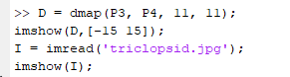

|  |  |
| --- | --- |
| A picture containing wall, indoor, white, photo  Description automatically generated  Original Disparity Map | Created Disparity Map |

How does the image structure of the stereo images affects the accuracy of the estimated disparities?

* The image used in part (d) were much more blur compared to the images used in (e) which may have resulted in the disparity map being incorrectly mapped at some regions like the walkway and the road.